THE CORPORATION FOR FINANCING AND PROMOTING TECHNOLOGY  -------------  No.: 68/TTr-FPT.HĐQT | SOCIALIST REPUBLIC OF VIETNAM  Independence – Freedom – Happiness  ------------------------------------  Hanoi, August 1st 2008

STATEMENT OF MANAGEMENT BOARD OF THE CORPORATION FOR FINANCING AND PROMOTING TECHNOLOGY
About: Decide and ratify changing Vietnamese name of FPT
----------------------

To: SHAREHOLDERS OF THE CORPORATION FOR FINANCING AND PROMOTING TECHNOLOGY

The Board of Management of the Corporation for Financing and Promoting Technology would like to express great honor and sincere thanks to all shareholders for your precious support for the past time.
Because the Company’s name is long and difficult to remember that can lead to mistakes in drafting, and not convenient for trading purposes, the Board of Management of FPT Corporation proposed to change Vietnamese name of FPT. We respectfully call for Shareholders’ General Meeting to review and ratify the following content:

- Original name:
Full name in Vietnamese: CÔNG TY CỔ PHẦN PHÁT TRIỂN ĐẦU TƯ CÔNG NGHỆ FPT

- New name:
Full name in Vietnamese: CÔNG TY CỔ PHẦN FPT

Please review the above content.
Thank you very much.

Place of receipt:  - As above;  - Supervisory Board;  - Administration Dept. | THE CORPORATION FOR FINANCING AND PROMOTING TECHNOLOGY  ON BEHALF OF MANAGEMENT BOARD  Chairman  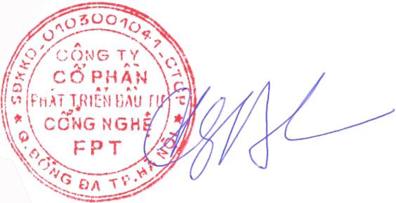  Truong Gia Binh

