THE CORPORATION FOR FINACING  AND PROMOTING TECHNOLOGY | SOCIALIST REPUBLIC OF VIETNAM  Independence – Freedom – Happiness
No. 01-09-2008/NQ-FPT.ĐHĐCĐ | Hanoi, September 25th 2008

RESOLUTION
About: Decide and ratify changing Vietnamese name of FPT

SHAREHOLDERS’ GENERAL MEETING OF THE CORPORATION FOR FINANCING AND PROMOTING TECHNOLOGY

According to Enterprise Law ratified by the National Assembly of the Socialist Republic of Vietnam on November 29th 2005;
According to Decision No. 178/QĐ-TTg dated February 28th 2002 by the Prime Minister about changing the ownership from State-owned Enterprise to Joint-stock Company;
According to the Charter of the Corporation for Financing and Promoting Technology (FPT);
According to Management Board Meeting Minutes No. 03-05.2008BBHĐQT/FPT dated May 13th 2008 of the Corporation for Financing and Promoting Technology (FPT);
According to the voting results in the Voting Report No. 01-09-2008/BBKP-ĐHĐCĐ dated September 16th 2008,

RESOLUTION:

Article 1. Decide to change the Company’s Vietnamese name of “The Corporation for Financing and Promoting Technology”, details are as follows:

Original name:
Full name in Vietnamese: CÔNG TY CỔ PHẦN PHÁT TRIỂN ĐẦU TƯ CÔNG NGHỆ FPT
New name:
Full name in Vietnamese: CÔNG TY CỔ PHẦN FPT

Article 2. This Resolution takes effect on the day of signing.

Article 3. Chairman and all members of the Board of Management, the Board of Directors, Finance Department, Investor Relations Department, related departments/divisions and all staff of the Corporation for Financing and Promoting Technology FPT are responsible to carry out this Resolution./.

Place of receipt:  - Members of the Board of Management;  - Supervisory Board;  - Investor Relations Dept.;  - Administration Dept. | ON BEHALF OF MANAGEMENT BOARD  CHAIRMAN  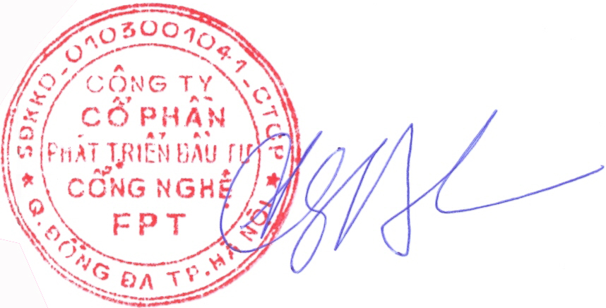  Truong Gia Binh

