THE CORPORATION FOR FINANCING AND PROMOTING TECHNOLOGY – FPT  Address: 89 Lang Ha, Dong Da District, Hanoi city  Business Registration Certificate No. 0103001041 issued by Hanoi Department of Planning and Investment on May 13th 2002, (the 17th amendment ratified on September 25th 2008) |  | SOCIALIST REPUBLIC OF VIETNAM  Independence - Freedom - Happiness
*00001* | SHAREHOLDER’S OPINION

To: The Board of Management of the Corporation for Financing
and Promoting Technology – FPT

Full name of Shareholder:
Representative of Shareholder:
Residential Address (or Head office if Shareholder is an organization):
ID/Passport Number (or Business Number if Shareholder is an organization):
Date of issue: Place of issue:
Number of shares owned (or authorized) as of November 11th 2008:
In words:

After reviewing the Document No. 6291/TTr-FPT.HĐQT dated November 5th 2008 by the Management Board of the Corporation for Financing and Promoting Technology and other related documents, I would like to submit my opinion as follows:

- Item 1: Ratify listing additional bonus shares to current shareholders from surplus capital in order to increase chartered capital. The number of shares issued accounts for 50% of chartered capital on issuance date.

Approve:  | Disapprove:  | Neutral: 

- Item 2: Ratify cancelling issuance plan of additional shares in order to increase chartered capital. The number of shares does not account for more than 10% of chartered capital on issuance date according to Resolution of 2007 Shareholders’ Extraordinary Meeting dated November 20th 2007.

Approve:  | Disapprove:  | Neutral: 

- Item 3: Ratify changing English name of the Company “The Corporation for Financing and Promoting Technology” as follows:
  - Current name : The Corporation for Financing and Promoting Technology
  - New name : FPT Corporation

Approve:  | Disapprove:  | Neutral: 

(Please sign and seal next page)

Deadline: This form should be sent to the Corporation for Financing and Promoting Technology no later than December 5th 2008 (As attested by date on postmark).
If this form is not to be received by the above deadline, the vote will be recorded as “approve”.

Please reply to: Investor Relations Department of the Corporation for Financing and Promoting Technology; Address: FPT Cau Giay Building, Pham Hung Road, Cau Giay District, Hanoi, Vietnam; Tel: 84.4. 3730 1515 - Fax: 84.4. 3768 9079

ON BEHALF OF MANAGEMENT BOARD  CHAIRMAN  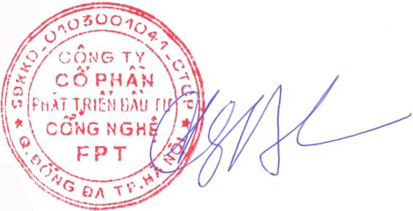  Truong Gia Binh | ……………..., date……….month………2008  SHAREHOLDER  Sign with full name  (seal if Shareholder being an organization)

