THE CORPORATION FOR FINANCING AND PROMOTING TECHNOLOGY | SOCIALIST REPUBLIC OF VIETNAM  Independence – Freedom – Happiness
No.: 01.12-2008/NQ-FPT.ĐHĐCĐ | Hanoi, December 15th 2008

RESOLUTION
About: Decide and ratify listing additional bonus shares to current shareholders from surplus capital, cancelling issuance plan of additional shares to increase 10% of charter capital and changing English name of the Company

SHAREHOLDERS’ GENERAL MEETING OF THE CORPORATION FOR FINANCING AND PROMOTING TECHNOLOGY

According to Enterprise Law ratified by the National Assembly of the Socialist Republic of Vietnam on November 29th 2005;
According to Decision No. 178/QĐ-TTg dated February 28th 2002 by the Prime Minister about changing the ownership from State-owned Enterprise to Joint-stock Company;
According to the Charter of the Corporation for Financing and Promoting Technology (FPT);
According to Management Board Meeting Minutes No. 02-10.2008BBHĐQT/FPT dated October 27th 2008 of the Corporation for Financing and Promoting Technology (FPT);
According to Management Board Meeting Minutes No. 03-10.2008BBHĐQT/FPT dated October 29th 2008 of the Corporation for Financing and Promoting Technology (FPT);
According to the voting results in the Voting Report No. ………/BBKP-ĐHĐCĐ dated ………. 2008,

RESOLUTION:

Article 1. Ratify listing additional bonus shares to current shareholders from surplus capital in order to increase chartered capital. The number of shares issued accounts for 50% of chartered capital on issuance date.

Article 2. Ratify cancelling issuance plan of additional shares in order to increase chartered capital. The number of shares does not account for more than 10% of chartered capital on issuance date according to Resolution of 2007 Shareholders’ Extraordinary Meeting dated November 20th 2007.

Article 3. Ratify changing English name of the Company “The Corporation for Financing and Promoting Technology” as follows:
  - Current name : The Corporation for Financing and Promoting Technology.
  - New name : FPT Corporation.

Article 4. This Resolution takes effect on the date of signing.

Article 5. Chairman and all members of the Board of Management, the Board of Directors, Finance Department, Investor Relations Department, related departments/divisions and all staff of the Corporation for Financing and Promoting Technology (FPT) are responsible to carry out this Resolution./.

Place of receipt:  - Members of the Board of Management;  - Supervisory Board;  - Investor Relations Dept.;  - Administration Dept. | ON BEHALF OF MANAGEMENT BOARD  CHAIRMAN  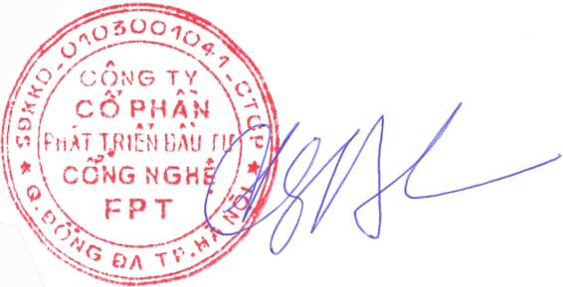  Truong Gia Binh

