THE CORPORATION FOR FINANCING AND PROMOTING TECHNOLOGY | SOCIALIST REPUBLIC OF VIETNAM  Independence – Freedom – Happiness
No.: 6291/TTr-FPT.HĐQT | Hanoi, November 5th 2008

STATEMENT OF THE CORPORATION FOR FINANCING AND PROMOTING TECHNOLOGY
About: Decide and ratify listing additional bonus shares to current shareholders from surplus capital and cancel issuance plan of additional shares
to increase 10% of charter capital

To: SHAREHOLDERS OF THE CORPORATION FOR FINANCING
AND PROMOTING TECHNOLOGY

The Board of Management of the Corporation for Financing and Promoting Technology would like to express great honor and sincere thanks to all shareholders for your precious support for the past time.
We respectfully submit to Shareholders’ General Meeting to review and ratify the following items:

- Item 1. According to Decree No. 14 of Government (Article 10 and 13), when additional shares are issued, the approval of Shareholders’ General Meeting about listing is required before shares are listed and traded. The Board of Management of FPT respectfully submits to Shareholders’ General Meeting to review and ratify listing additional bonus shares to current shareholders from the surplus capital in order to increase chartered capital. The number of shares issued accounts for 50% of chartered capital on issuance date according to Resolution of 2007 Shareholders’ General Meeting dated April 22nd 2007 and Resolution of 2007 Shareholders’ Extraordinary Meeting dated November 20th 2007.

- Item 2. Based on business performance, unfavorable conditions of the market and to ensure shareholders’ rights, the Board of Management of FPT respectfully submits to Shareholders’ General Meeting to review and ratify cancelling issuance plan of additional shares in order to increase chartered capital. The number of shares does not account for more than 10% of chartered capital on issuance date according to Resolution of 2007 Shareholders’ General Meeting dated April 22nd 2007 and Resolution of 2007 Shareholders’ Extraordinary Meeting dated November 20th 2007.

- Item 3. The Corporation for Financing and Promoting Technology – FPT submitted to shareholders’ approval by collecting shareholders’ opinions in documents about changing the Company’s Vietnamese name of “ The Corporation for Financing and Promoting Technology” (according to Resolution of 2008 Shareholders’ Extraordinary Meeting No. 01-09-2008/NQ-FPT.ĐHĐCĐ dated September 25th 2008). However, FPT needs to change its English name at the same time due to the request of Hanoi Department of Planning and Investment. Therefore, the Board of Management of FPT convened and ratified changing the Company’s English name and submitting for shareholders’ approval by collecting shareholders’ opinions in documents as follows:
  - Original name : The Corporation for Financing and Promoting Technology.
  - New name : FPT Corporation.

Please review the above contents.
Thank you very much./.

Place of receipt:  - As above;  - Supervisory Board;  - Administration Dept. | ON BEHALF OF MANAGEMENT BOARD  CHAIRMAN  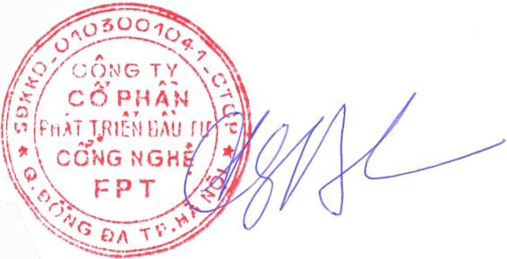  Truong Gia Binh

